***QUESTION 1***

Tasks:

● Create a directory /data/devops and add 3 files (file1.txt, file2.txt, file3.txt) using touch.

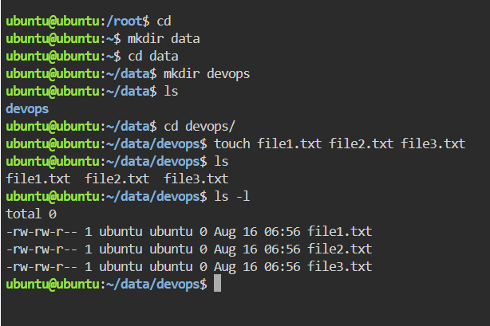

● Create a group named devgroup and add an existing user to this group.  
  
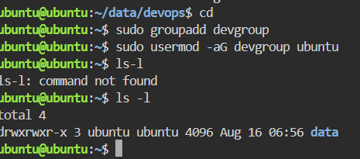

Change the group ownership of all files in /data/devops to devgroup using a single command.

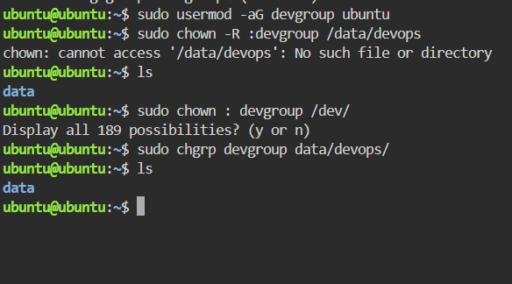

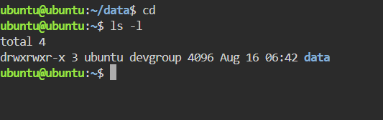

Give the group read and write permissions on these files without affecting owner permissions.

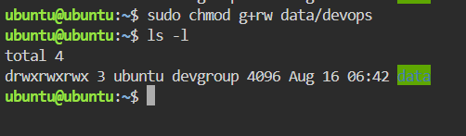

Copy /data/devops directory recursively to /backup/devops and ensure permissions and timestamps are preserved during the copy.

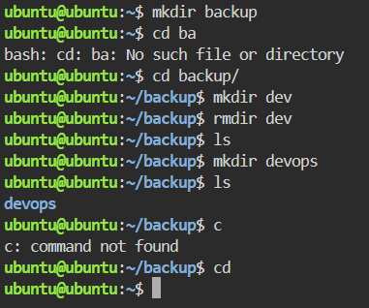

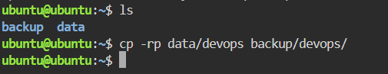

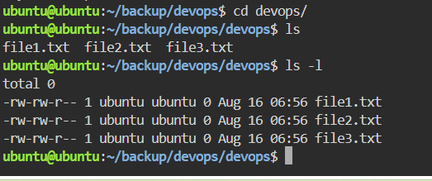

***QUESTION 2***

Update the package index and upgrade all packages to the latest version.

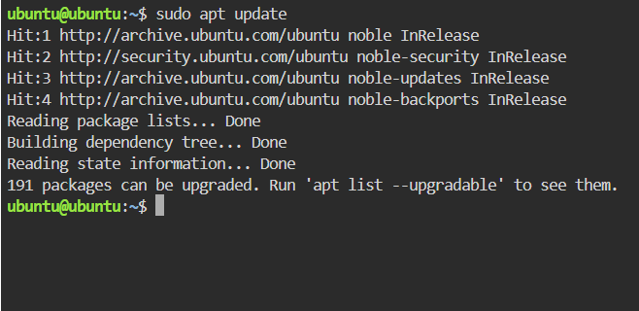

Install and uninstall appropriate packages for calendar and ping utility using a single APT command.  
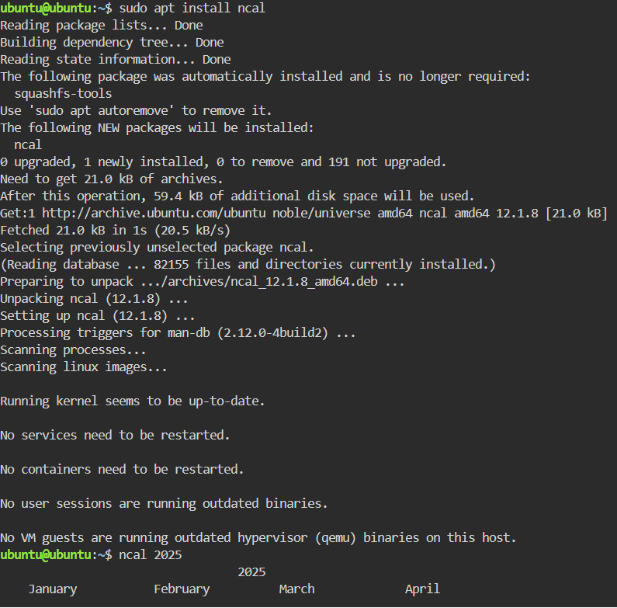

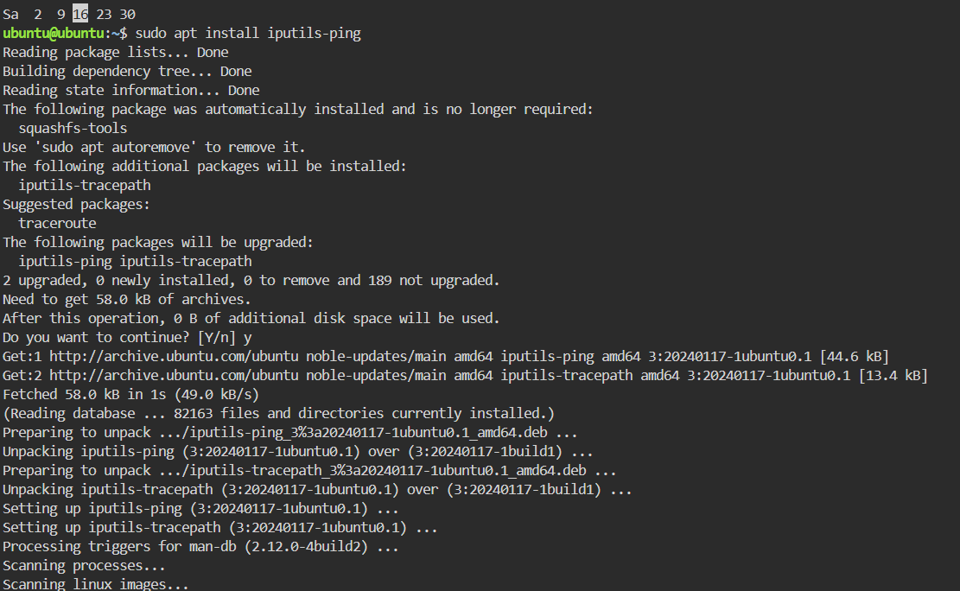

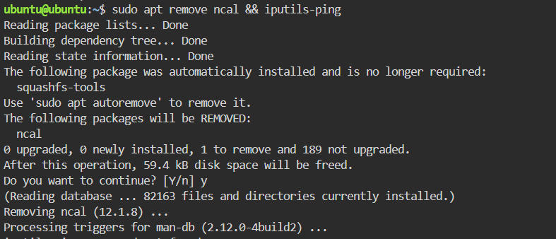

Remove any installed package safely using APT.

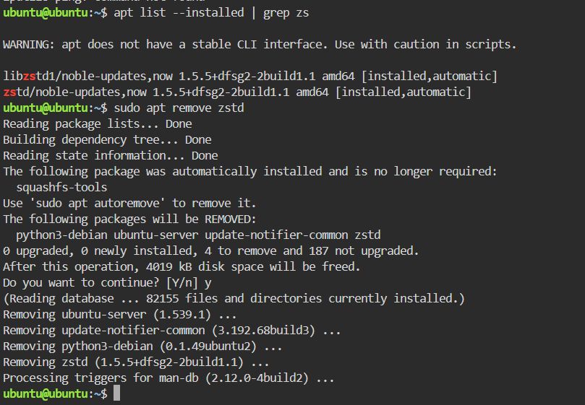

Show how to check the package version and list all installed packages.

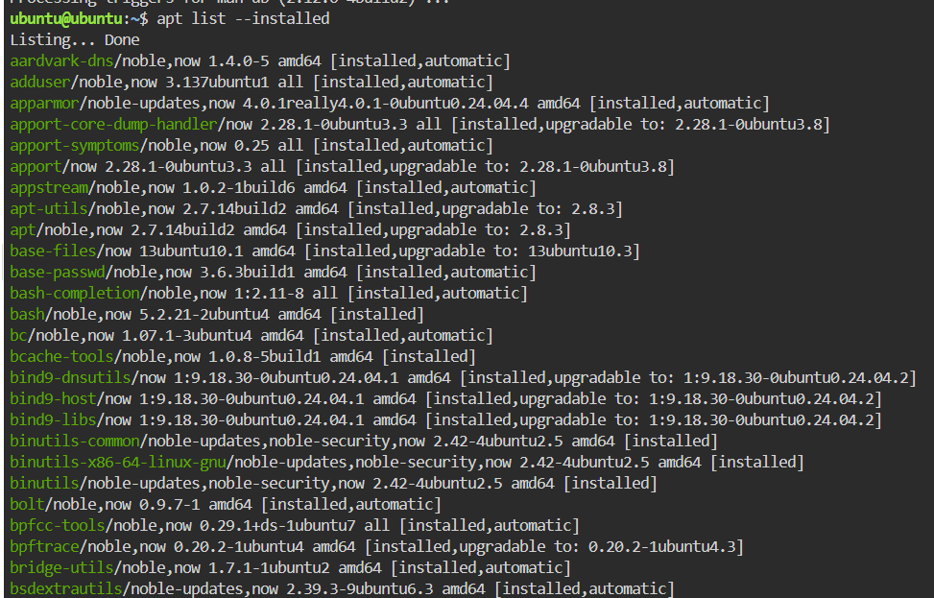

Explain how APT manages dependencies during installation

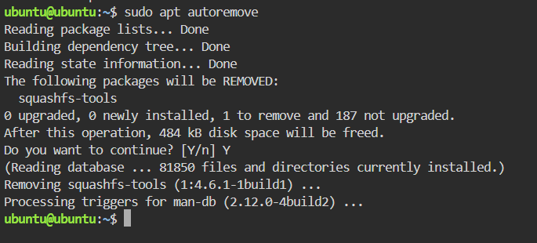

***QUESTION 3***

Create 2 new users: devuser1 and devuser2.

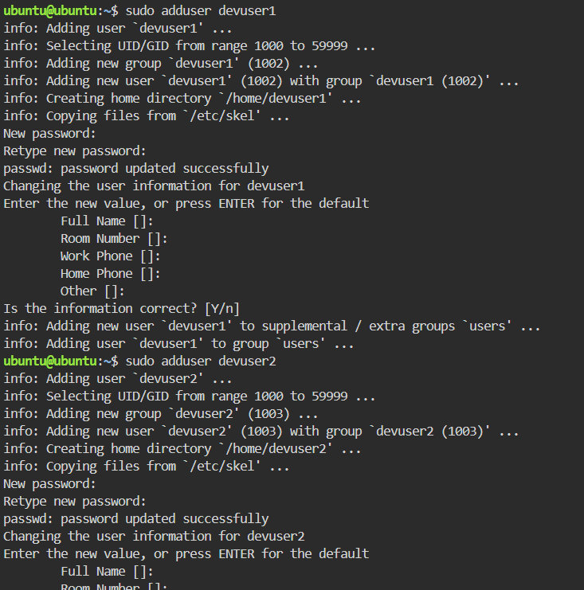

Create a directory /project-data and set ownership to devuser1: devuser1.  
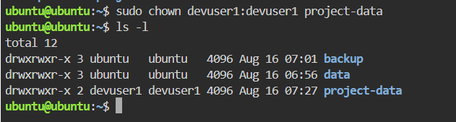

Give devuser2 read and execute permissions on /project-data but no write permission.

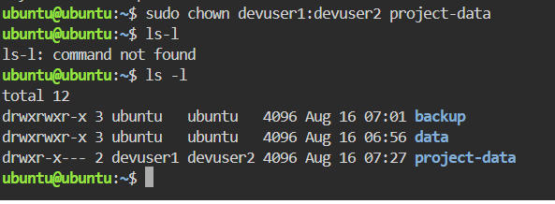

Demonstrate permission changes using symbolic (u,g,o) and numeric (chmod 755) methods.

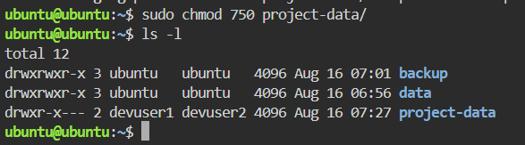

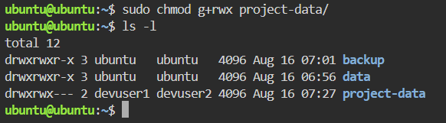

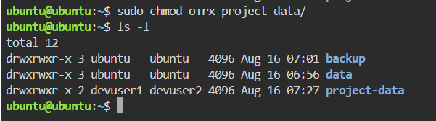

Use chown to transfer ownership of a file from devuser1 to root.

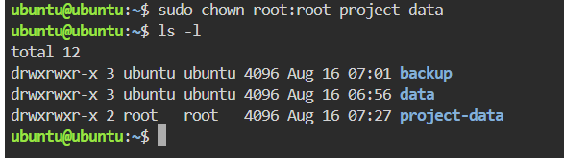

***QUESTION 4***

Create a new file devops_notes.txt using vi.

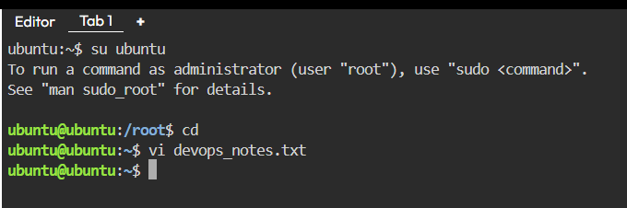

Insert at least 10 lines of text in Insert Mode

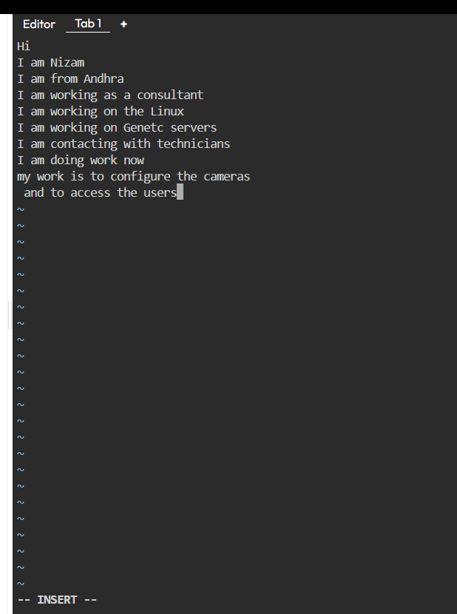

Save and exit using Command Mode commands (:wq)

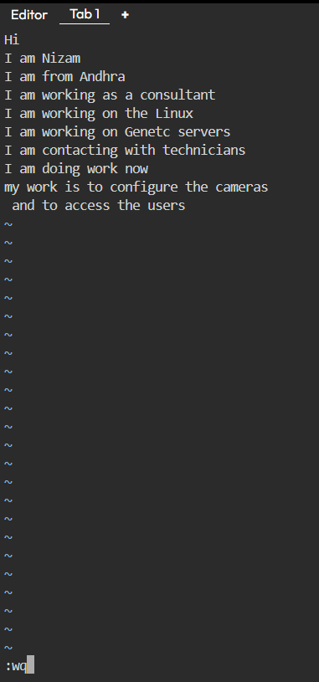

Reopen the file, delete 2 lines using Normal Mode.  
  
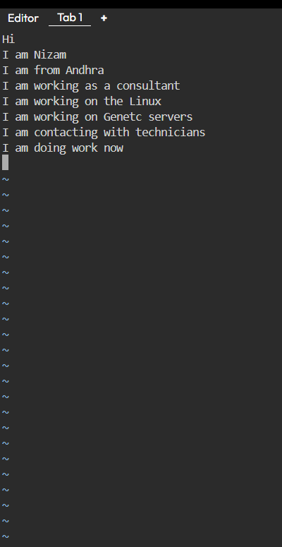

Add a line at the end of the file without disturbing existing content

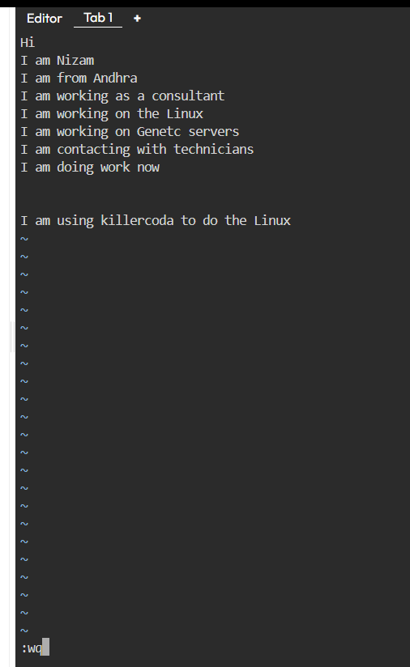

***QUESTION 5***

Create a file secure.txt and give read/write permission to the owner, read-only for group, and no permission for others using chmod numeric values.

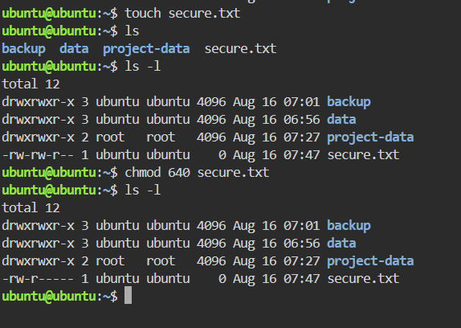

Change group ownership of secure.txt to devgroup.

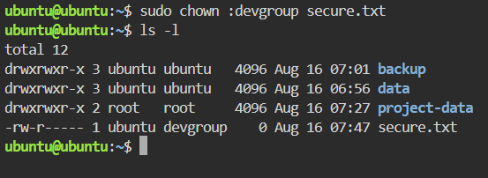

Explain how rwx translates to numeric values and why 755 is commonly used for directories.

**7 (rwx)** → Owner can read, write, and enter (execute) the directory.

**5 (r-x)** → Group can read and enter, but not modify.

1. **(r-x)** → Others can read and enter, but not modify.

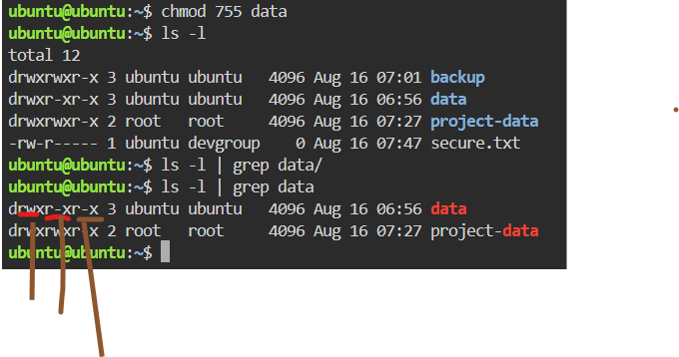

1🡪 rwx for root or owner  
2🡪 r-x for group  
3🡪 r-x for others

Demonstrate how to remove execute permission for others on a directory.  
Verify permissions using ls -l and capture the output.

